湖北花鼓戏《赵氏孤儿》（2002年首演）
湖北省实验花鼓戏剧院

湖北花鼓戏《赵氏孤儿》2002年上演以来深受民众赞美。演出至今已超过300场。

我们这部剧的演出特点是：

- 淡化复仇故事，突显人间纯情。将朝廷争斗、诛奸复仇的情节简化，把主人公程婴的妻子王氏与孤儿亲生母公主等人物推至幕前并细腻演示，着重展现人性、人情。

- 强化演唱戏份，彰显剧种特色。在“放孤”、“辞孤”等戏中，将大段说白改为演唱，并增加唱词，充分显示地方戏曲的唱腔艺术。

- 戏化民俗语言，体现草根风味。将语言移植为方言语韵，比如将贯穿全剧的“儿歌”变为江汉平原一带的民歌韵味，尽力加强地方文化特色。

――吴培义（制作人）

The Orphan of Zhao (Hubei Flower-drum Opera or huaguxi, premiered 2002)
Hubei Experimental Huaguxi Theatre

Huaguxi or Flower-drum Opera is one of the regional song-dance theatres in the Hubei area, with a history of about 150 years. Developed from the local folk song and dance, it has been popular in the countryside.

Premiered in 2002, The Orphan of Zhao has given over 300 performances. It has been warmly welcomed by both urban and rural audiences.

The main features of the production are as follows:

- Emphasizing love and humanity while playing down the story of revenge. The plots of intrigue in court and revenge against evil were simplified, whereas the protagonist’s wife and the orphan’s mother (the Princess) were given prominence. Their feelings towards their sons were depicted through touching songs and beautiful movements.

- Reinforcing the singing parts to highlight the characteristics of the huaguxi. In scenes like ‘Han Jue Releases the Orphan’ and ‘Bidding Farewell to the Orphan’, large sections of monologues were adapted into songs with additional lines of lyrics. Thus the art of aria singing in the local opera is underscored.

- Using local idioms and expressions, and the rise and fall of the tones of the dialect, the production conveys the grass-roots culture. For example, the use of a nursery rhyme throughout the opera adopted a folk tune to evoke the local colour of the Jianghan Plain in the performance.

-- Wu Peiyi (Producer)
Captions:
Flower-drum Opera 1 | 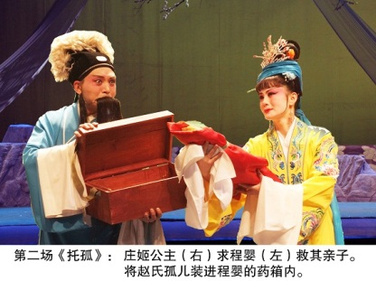 | 庄姬公主请求医生程婴把婴儿装进药箱，偷偷混出王宫。  Princess Zhuang Ji asks Doctor Cheng Ying to put the orphan in his medicine chest and smuggle him out of the palace.
Flower-drum Opera 2 | 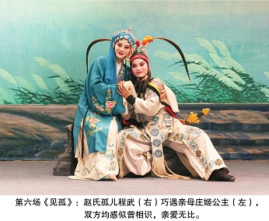 | 十六年后，孤儿长大成人，打猎途中巧遇生母庄姬。互不知道对方是谁，但是感觉似曾相识。  Sixteen years later, the orphan meets his natural mother Zhuang Ji during a hunting trip. They immediately feel an affection for each other although they have never met before.
Flower-drum Opera 3 | 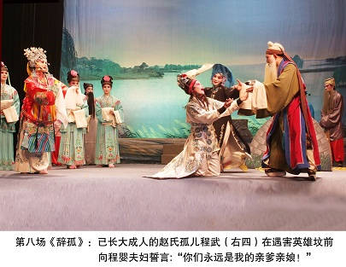 | 知道自己的身世之后，孤儿与生母公主前来祭奠所有遇害的英雄。孤儿向程婴夫妇发誓：“你们永远是我的亲爹亲娘！”  Having learnt his true life story, the orphan and his natural mother pay tribute to all the heroes who have sacrificed their lives for them. The orphan swears to Cheng Ying and his wife: ‘You will always be my real parents!’
照片由湖北省实验花鼓戏剧院提供
Courtesy of Hubei Experimental Huaguxi Theatre

