西洋歌剧《赵氏孤儿》（2011年首演）
中国国家大剧院

歌剧《赵氏孤儿》是国家大剧院推出的第三部中国题材的原创歌剧。

2011年，国家大剧院将这一被世界所熟知的中国传统文化经典题材，以西洋歌剧的形式，从中国的精神理念和审美视角，来呈现这一宏大的主题。希望以此还原古典大义，突出中华民族“舍生取义”的价值观，凸显中国义士的传统精神，让世界从精神的层面来认识中国。

一部歌剧的音乐形态至关重要。在乐队方面我们作曲家将民乐融合进了交响乐当中，营造出动听和独特的效果。全剧悲壮，感人。程婴、韩厥、公孙杵臼等仁义之士，为忠为义前赴后继，舍生捐命之情状，充分展示了中国春秋时期“士”的精神风范。
――关渤（制作人）

The Chinese Orphan (Western operatic style, premiered 2011)
National Centre for the Performing Arts, China

Chinese artists started composing and performing Western style of opera from the 1930s. The Chinese Orphan is the third original opera produced by the National Centre of Performing Arts (NCPA).

In 2011, NCPA presented the world-renowned Chinese story in the style of Western opera, while retaining the Chinese ideology and aesthetic perspective. The opera was intended to further the world’s understanding of China on a spiritual level by representing the classic Chinese concept of ‘righteousness’. It was revealed in the opera that sacrificing one’s life in this way represented the sense of value, and was what a righteous person should do.

The form of music is vital to an opera. Our composer and orchestra integrated folk music into symphony, creating a beautiful and unique effect. The opera was solemn, stirring and touching. The upright men like Cheng Ying, Han Jue, Gongsun Chujiu, laid down their lives for a just cause, displaying the spirit of gentlemen during the Spring-Autumn Period (770BC－476BC).

-- Guan Bo (Producer)

Captions:
WO 1 | 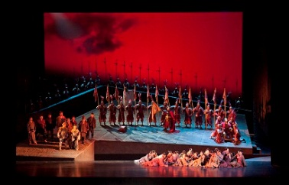 | 找不到赵氏孤儿，屠岸贾下令杀死所有与赵家孩子年龄相仿的幼童。前排歌队为恐慌的母亲。  Unable to find the orphan of Zhao, Tu’an Gu demands all the children of a similar age to the orphan be killed. The choir in the front are panicked mothers.
WO 2 | 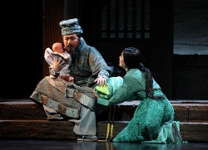 | 面对两个婴儿，程婴的妻子渐渐明白了丈夫的想法，她悲痛绝望。  Faced with two babies, Cheng Ying’s wife gradually understands her husband’s decision. She is devastated.
WO 3 | 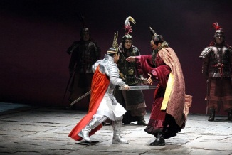 | 赵氏孤儿手刃仇敌屠岸贾。  The orphan of Zhao kills Tu’an Gu with a sword.
照片由中国国家大剧院提供
Courtesy of the National Centre for Performing Arts, China

